**ABSTRACT**

Embracing effective technologies to automatically detect the presence of bird or drone in the surrounding periphery is captivating need for latest technology like drone delivery system. The following work represents the solution to the problem of approachment of bird towards a parcel delivering drone. Lot many bird species now a days are already having a pressure of loss of their habitat it will be difficult for them to survive in the world of drones and as their feeding is always being disturbed by the moving drones in the sky. Our basic goal is to identify which bird is approaching towards the drone and likewise take respective measures in order to provide safe delivery to the owner. This will also ensure safe delivering of a parcel to a owner as well as it will also maintain the bird species in a ecosystem without damaging them or causing them any harm to their life.

**Keywords:** regression problem,drone technology ,object identification, drones , birds ,training,testing,accuracy,bird approachment.

**INTRODUCTION**

Drones have gotten so popular that they have become an elite sport and fun activity. One of the consortiums selected is led by the Bengaluru-based drone company Throttle Aerospace Systems, India’s first drone delivery service, that specialises in medical supplies, will begin operating in Karnataka soon but according to WHO reporting 2021, approximately 1.3 million people die each year as a result of road traffic crashes [2]. 93% of the world's fatalities on the roads occur in low- and middle-income countries, even though these countries have approximately 60% of the world's vehicles [2]. Hence it is necessary for us to reduce the road traffic and save the life of people with the help of latest technologies using drones which will be used for physically delivering a product to any corner of the world. Drones prevents accidents because they physically deliver the commodity to particular consumers. Human delivery are often exposed to hazardous environments. When using drones, delivery person will no longer have to risk their lives from accidents. But the major obstacle for the drone is birds. What if birds flying in their aerial space damage the drones? What to do if birds are trying to damage the parcel from the drones? What to do if two drones cross each other? After going through the study of behaviour of birds it is clear that Using a standardized protocol applied to three different species of waterbirds, across 204 approaches, we demonstrated that in 80% of all cases one specific drone type could fly to within 4 m of the birds without visibly modifying their behaviour. After demonstrating that approach speed, drone colour and repeated approaches did not have any significant impact on bird reaction, but that approach angles had marked impacts across all three species. Impacts of drone colour (white, blue, black), approach angle (8) and flight speed (m s21) on bird behaviour across 204 approach flights conducted in three bird species. The impact is rated as the percentage of approaches to within 4 m of the birds during which animals did not show visible reactions[1].

Within 4 m of the birds without visibly modifying their behaviour. We also demonstrated that approach speed, drone colour and repeated approaches did not have any significant impact on bird reaction, but that approach angles had marked impacts across all three species.

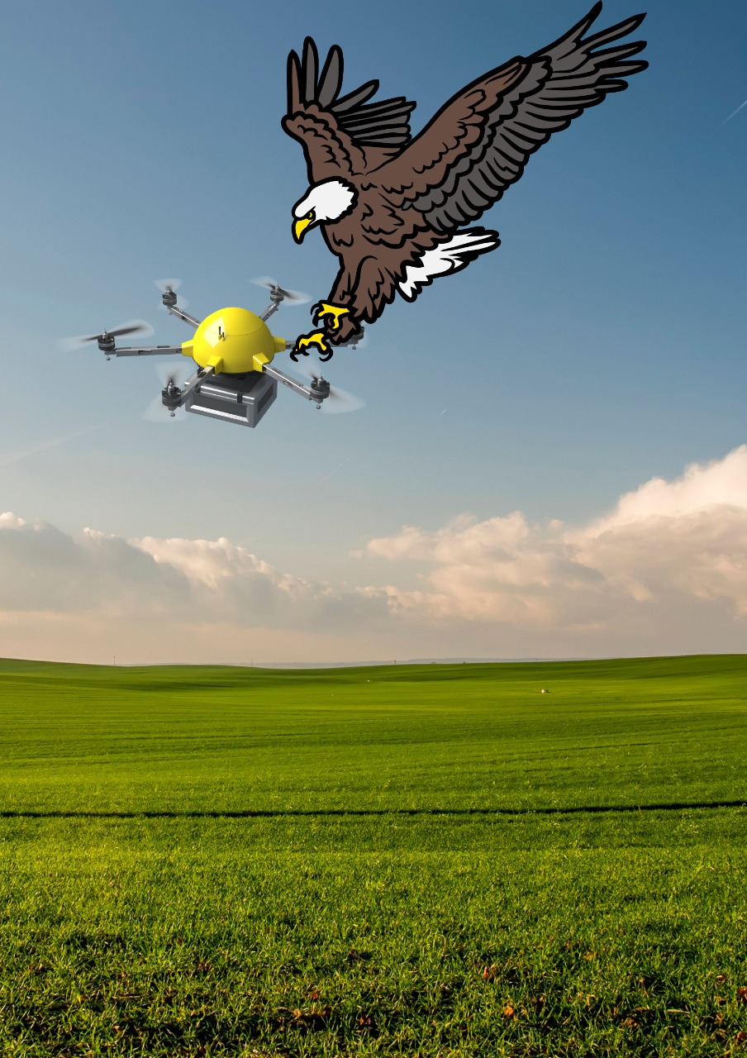

**Economic damage to drone**

According to the American Security Project, unclassified reports show that the MQ-9 Reaper drone used for attacks in Pakistan has a single unit cost of US$6.48 million and an operational cost of close to US$3 million[3]. One of the example is the unmanned MQ-9A Reaper quickly lost power and hit the ground about a minute after its take off from Hancock International Airport in Syracuse, N.Y., resulting in a loss of over $6 million in government property, the Air Force accident investigation board headed by Lt. Col. Brian E. Prichard said. Experiment realized that birds could indeed be scared off by drones. But how much they were scared depended on the angle of approach and the drone’s position relative to the bird. Birds tended to be scared more when the drone approached at right angles(90 degrees) to them and if they came from above.

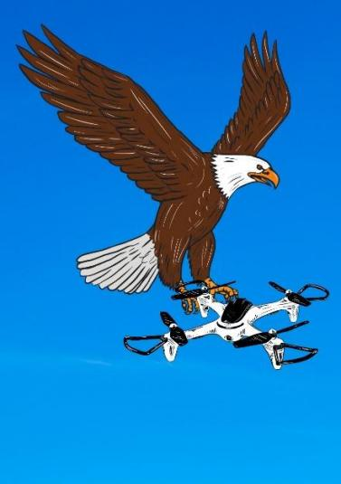

Flocks of birds also showed a much stronger response than lone birds. Strong and repellent scents and smells like pepper or even essential oils may deter birds for a time. To get rid of birds completely with smells, you would have to consistently spread the scents all over their roosting and nesting spots to make the habitat unliveable. Birds hate strong smells, but again, this is likely not a viable long-term solution.

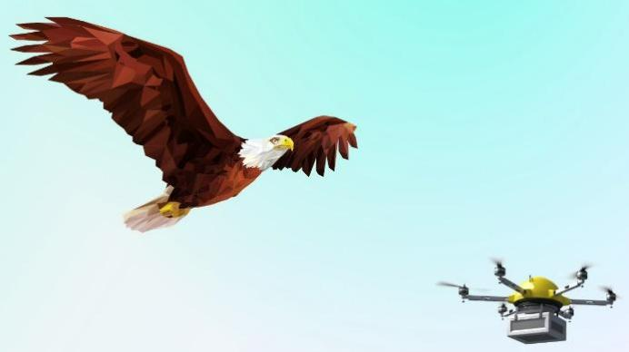

Vinegar spray works as a natural repellent for many species of birds because it has a pungent odour from the acetic acid and can cause irritation if it touches the skin. Its topical effects are similar to chili powder which is another common bird deterrent. In order to get rid from the birds like vulture , eagle, etc. Drones will be releasing strong and repellent smells which will be hated by the birds. Small birds have tendency to ignore the drones but not the same case with big birds like Kite, Eagle, etc. So this will avoid the disturbance of big birds while delivering a parcel. Amazon have started drone delivery system which is design to safely get the product to customers in 30 minutes or less using drones. But what’s the assurance of delivering the parcel as it is to the client without any disturbance of any bird during the journey of drone delivery.

**METHODOLOGY**

The first YOLO model was introduced by Joseph Redmon et all in their 2015 [paper](https://arxiv.org/pdf/1506.02640.pdf) titled “You Only Look Once: Unified, Real-Time Object Detection”. YOLO is an abbreviation for the term ‘You Only Look Once’. YOLO is an algorithm that detects and recognizes various objects in a picture (in real-time). Object detection in YOLO is done as a regression problem and provides the class probabilities of the detected images.

YOLO algorithm employs convolutional neural networks (CNN) for object detection in real-time. As the name suggests, the algorithm requires only a single forward propagation through a neural network to detect objects.

This algorithm is popular because of its speed and accuracy. It has been used in various applications to detect traffic signals, people, parking meters, and animals. In our project we are employing YOLOv5 which was launched by Ultralytics in June 2020 and is now the most advanced object identification algorithm available.

Following are the tools used in YOLOv5

***I. PyTorch***

PyTorch is an optimised deep learning tensor library based on torch and python and is used in CPUs & GPUs applications. It is favored by deep learning frameworks as it uses dynamic computation graphs and is completely pythonic.

***II.Google Colab***

Google Colab allows everybody to write and implement python code through a browser and it is used specifically in deep learning, data analysis, etc.

***III.Python v3***

PythonV3 was released in december 2008. This language has specially the feature of how built-in objects like dictionaries and string work which are changed considerably, and a lot of features have finally been removed.

***IV.Pandas***

Pandas is a flexible, open source data analysis tool. It is used in data manipulation. Pandas are basically used for data analysis. IT aims to be a high level fundamental building block for real world data analysis.

***V.Matplotlib***

Matplotlib is used for data visualisation in python. It is a library for static and animated visualization. It has a customized visual style and layout. It is exported to many file formats.

***VI.TensorFlow***

TensorFlow is a free and open source software library for artificial intelligence and machine learning. It particularly focuses on training and conclusion of deep neural networks.

***VII.Keras***

Keras acts as an interface for the TensorFlow library. It is an open source, free source python library for valuating deep learning models.

***VIII.Anaconda***

Anaconda is a distribution of python and R programming, etc. Comtypes, conda, conda-build are the names of the version included in anaconda for python.

***IX.NumPy***

NumPy provides random numbers generators, linear algebra, mathematical functions, etc. NumPy is a library for python programming which supports large data, multidimensional array and matrices, etc

***X.SciPy***

It is an open source python library used for technical computing. It is also used for scientific analysis. It stands for scientific python and provides different functions for optimization, signal processing.

***XI.Pycharm***

Pycharm is a python integrated development environment. It is widely used for application development. Itt offers autocomplete and other features to help you to get started.

After importing YOLO datasets, which contains the images of birds and a folder which consists of drone dataset. These 60 images of birds are trained into datasets. The makesense.ai is a free-to-use online tool for labeling photos. The Makesenese.ai website provides us with data labeling the images by bounding boxes by mentioning their name. After this labeling process validation is done for output showing.

Accuracy is done by separating data from analysis and repeating this analysis again and again. Accuracy is nothing but the accuressness of the result generated by the image to detect the particular thing.

**Representation of trained data by graph of Bird Detection:**

**Process of bounding boxes:**

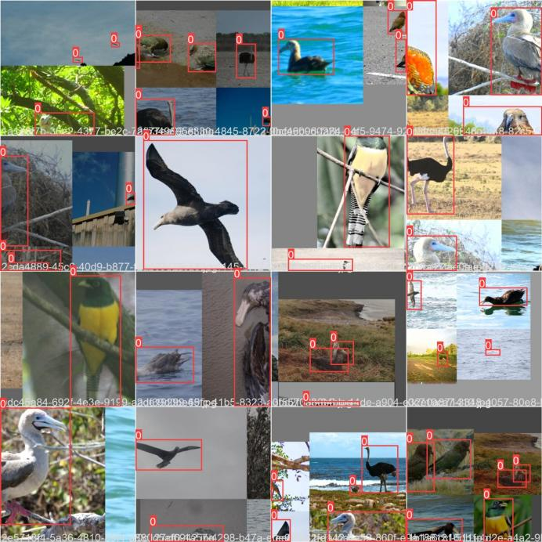

**Process of Labeling:**

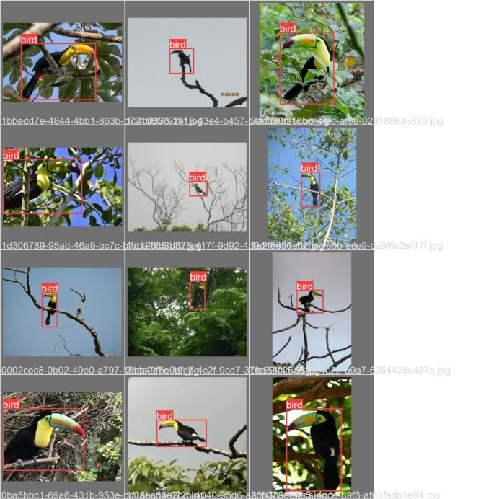

**Accuracy per image:**

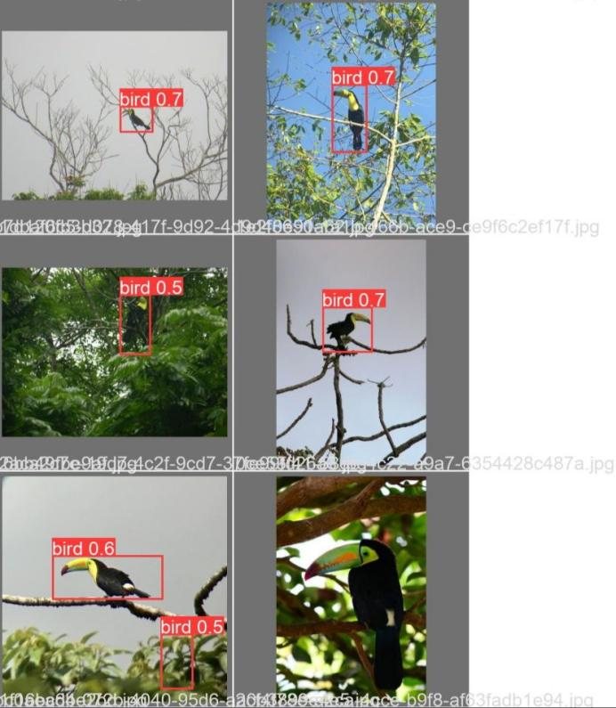

**RESULT:**

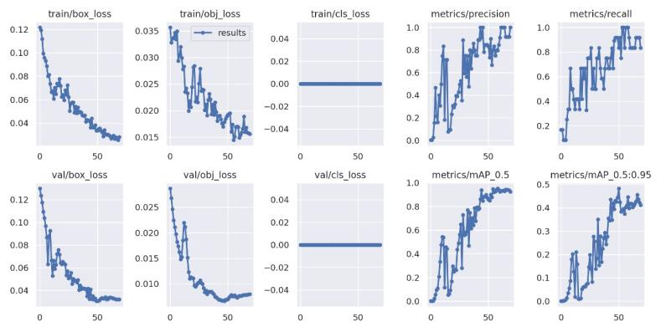

Initially we have taken **BIRD 400 –SPECIES IMAGE CLASSIFICATION** datasets. It contains various folders of various species. After creation of bounding boxes on the images,labeling is done on the each and every image of the data set resulting into training these images in Yolo V5 algorithm. After this process we have tested some images from given set of images which was compared by our system with the trained data. Accuracy of every image detection was manipulated by the system which given us clear idea of the percentage of correctness of prediction . We collected 1480 species of birds.The accuracy of the training process is 93.3%. This result is relatively high.Hence the proposed solution is based on the different techniques of image processing.We implemented the proposed solution of Object detections using YOLOv5 algorithum. Our experiments are setup and run on an Intel Core i5 Quad 3.5 – GHz, 8 GB of RAM, Windows 11 64-bits. A single camera is setup and configured to monitor special zone and to record videos for experiments. In order to increase the accuracy we can expand our datasets . For applications like Amazon using drone delivery system , we can increase the accuracy by training large amount of data and including large number of images to the datasets.

**CONCLUSION**

Drone technology has been tested by military R & D since the 1930's. With the latest advancement in technology, drones have emerged as an innovative business for product distribution. Drones can become an important part in the daily life of people in fully establishing transportation and commercial use. The effects of urbanization may create city-specific challenges depending on the expansion of cities .One should observe that the pain challenges lie in handling of cameras or a lens and in detecting distinct drone .Hence testing and training datasets should be enlarge along with this characteristics. We infer thatunlike Amazon drone delivery, our system will be detecting from a far distance, whether to pause for a while, in order to pass fromthe birds or whether to release strong smellswhich will take birds away. .Currently the working efficiency of our system is approx 93.3%. In future we will try to increase the efficiency up-to 95-96%. In further process we will be testing dataset of two lakh images of various types of birds which will clear the accuracy of our system more precisely. Future research may investigate some additional features such as use of more datasets, realtime complexity etc. which will help us to understand different possible avenue and also for quantitative research.

**REFERENCES**

1. <https://royalsocietypublishing.org/doi/pdf/10.1098/rsbl.2014.0754>
2. <https://www.who.int/news-room/fact-sheets/detail/road-traffic-injuries>
3. <https://blog.dronebase.com/the-impact-of-drones-on-the-us-economy>